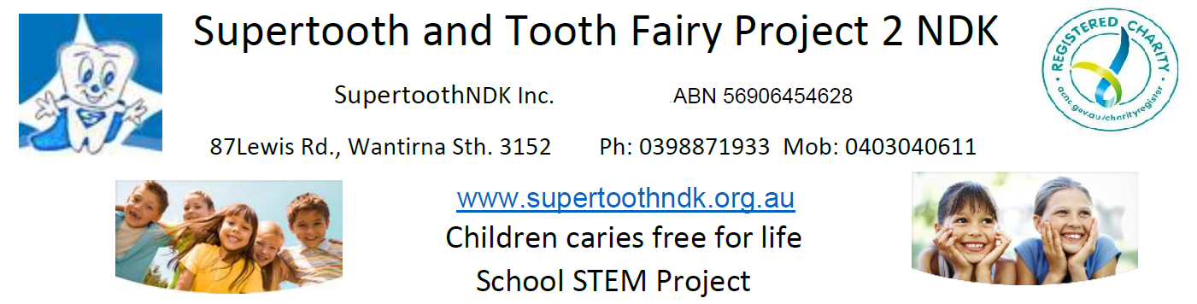
Tooth decay is Australia’s most prevalent health problem and the second most costly diet-related disease, affecting 23.7 adult teeth in a life time and increasing for children since 1999, with an economic impact comparable with that of heart disease and diabetes. Approximately $8.3 billion was spent on dental services in 2011-12, representing 6% of total health expenditure. In 2013-14, there were 63,910 preventable hospitalisations of children under the age of 9 due to dental causes in Australia, and dental expenditure through the Child Dental Benefits Scheme for tooth extractions was $20.5 million in 2014/15, and $96.1 million for fillings. End global decay and increase jobs and export markets.
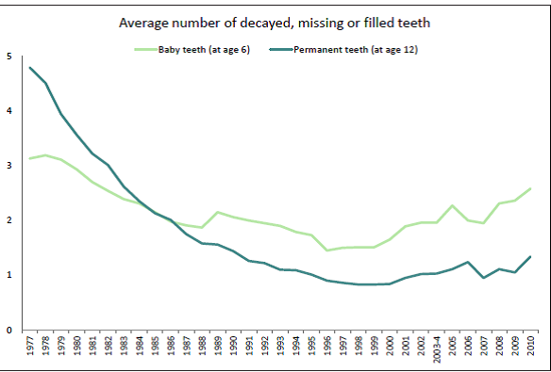
Measured as Decayed, Missing and Filled Teeth (DMFT) and also (DMFS) Surfaces in the 2012-14 survey, caries incidence started to increase for children in 1999 and fluctuated down and up twice since 2006 and back down to the 2000 level in 2012-14 but may be up again in 2019 but we haven't got regular collection of DMFT since 2010 or whole of population data that also focuses on where food is trapped, brushing can't reach and most cavities occur. It is still important to have a regular anual DMFT data but for all age groups and with additional data that targets cavities or fillings between teeth and inside pit and fissures where food is trapped, most cavities occur and brushing can’t reach, as well as other surfaces that are easy to brush that don’t develop many cavities. Also back teeth with sealants like in www.supertoothndk.org.au
Also, the data records of dentists are not transferred to a national data base like My Health Record nor do they give a more relevant and effective indication of oral health that includes fissure sealants, cavities between teeth and inside pits and fissures where food is trapped, brushing cannot reach and most cavities occur as well as other surfaces where brushing has easy access and few cavities occur, like on the pilot website www.supertoothndk.org.au and database. Dentists should give patients this information after each examination so families and individuals can monitor and compare their oral health with any post code, state or national averages for each age group on a suitable national database like www.supertoothndk.org.au
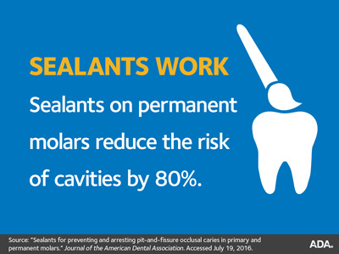
The 2012-14 national surveys fail to show that over 80 percent of cavities occur inside pit and fissure developmental faults in back teeth, or that dentists prevent these cavities by placing costly sealants over chewing surfaces to block food being trapped, which indicates that not leaving food on teeth is the most effective method of tooth care and should be the main feature of oral health promotion, as well as avoiding carbohydrate rich treats like sugar confection between meals or at the start of a meal so sugar is not the first to be trapped and forced deep into pit and fissure faults where resident plaque bacteria change any carbohydrates like sugar or starch to acid that demineralizes teeth.
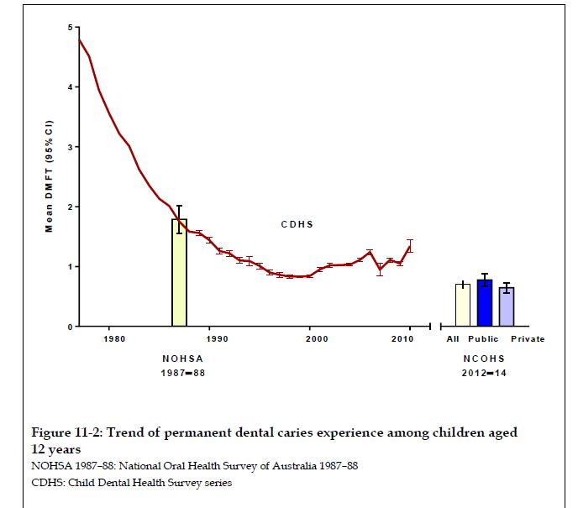
It is important to understand the dynamics of how food is trapped and displaced inside pits and fissures where over 80% of cavities occur, to make informed decisions about tooth care and preventing tooth decay which is why we measured these developmental faults in extracted molar teeth with 3D X-ray tomography at La Trobe University with Dr. Bernadeta Ahrtari, which helped make glass models of a fissure that replicate how food is trapped and displaced under chewing pressure and that brushing with toothpaste has no access.
These glass models are easy to make from two squares of glass clipped together by a fold back paper clip and use in oral health STEM school education projects that can be videoed with smart phones and posted on YouTube like in www.youtube.com/supertoothndk to replicate how food is trapped and displaced and how brushing can't force fluoride toothpaste inside pit and fissure developmental faults. Also, to identify sealant foods that are hard to displace and are best to chew before eating meals or snacks to block food being trapped.
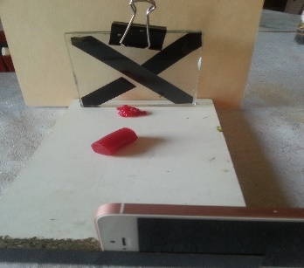
The glass models also helps identify the most effective food formulations to conveniently chew before meals or snacks or before brushing to block food being trapped, neutralize acid and aid remineralisation, which can stimulate enquiry, questioning and postulating answers in discussion and collaboration among students, teachers and families greatly increasing dental literacy.
Oral health STEM projects can be implemented in every year at school and also involve families helping show and photograph plaque at gum margins of teeth with food dye if brushing isn't adequate, dissolving egg shells in vinegar, testing for acid changes of the vinegar with litmus paper, harvesting plaque from between teeth with interdental brushes and testing for acid at different times after eating, plan class oral health surveys to get an average to compare with any post code, state or national averages, taking photos of teeth with mobile phones and posting on Facebook with comments about signs that should be seen by the dentist or compared with AI (artificial intelligence) that may be available soon on the internet. Making glass models of fissure, comparing how different foods are trapped and displaced or are hard to displace and act as sealants, identify foods like celery that force saliva into trapped food to dilute soluble sugar, even displace food, neutralise acid and aid remineralisation.
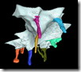
Secondary schools in different communities can also help further research with the Australian Synchrotron and 3D X-ray tomography that give 3D images to measure these faults that develop 80% of cavities by asking connected primary schools to ask parents of 9-12 year old children to collect the baby molar back teeth that fall out for the Tooth Fairy project and keep the teeth in a standard size envelope for each child with the child’s first name, date of birth, post code of birth and current post code.
We are planning a device to add 800 teeth at once to the robotic arm of the Australian synchrotron in the hope of finding out why some individuals don’t have faults in these teeth and how to best prevent the 80% of cavities that occur there in these faults to make the next big break through to end decay.
The first thing seems to be to get oral health STEM projects in schools and parents and teachers to register families on www.supertoothndk.org.au so that all stakeholders are more likely to participate.
Regards
Maurice White BDSc Melb
Main Points.
- Budget to end decay (2NDK)
- Reduce need for treatment and costs of treatment especially for rural and aboriginal communities that don’t have dental services.
- Annual collection of more relevant personal oral health data from dentists who should give a copy to each patient so they can compare with any post code, state or national averages for each age group like on www.supertoothndk.org,au
- Oral health STEM education projects in all schools to improve dental literacy.
- Research at the Australian synchrotron to measure and compare pit and fissure developmental faults in baby molar teeth from 9-12 year old children in different communities
- Glass Models of a fissure to replicate how food is trapped and displaced in STEM school projects and for industry to develop sealant foods to chew before eating meals or snacks to bock food being trapped and preventb80% of cavities.
- Tax on carbohydrate rich products like sugar confection to reduce consumption, obesity and decay.

