2019-20
Pre-Budget Submission

1 February 2019

friendlysocieties.org.au

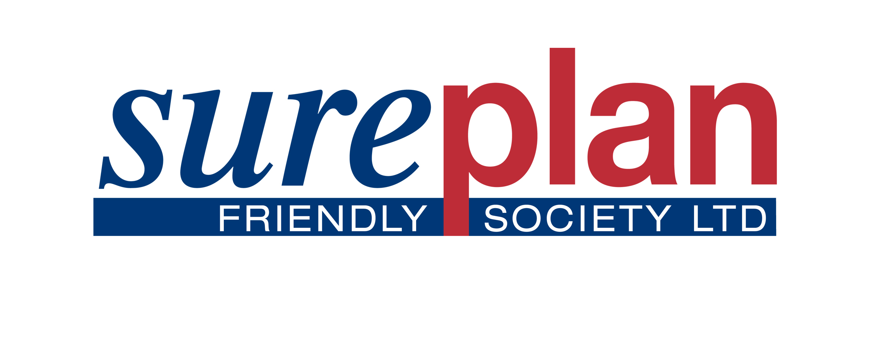
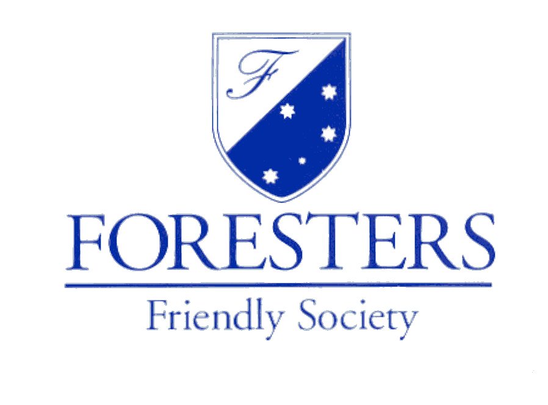
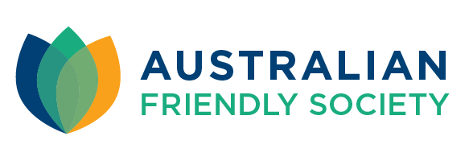
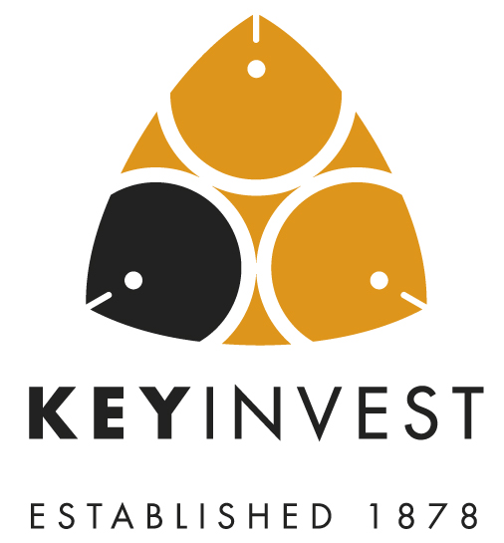

Executive Summary

On behalf of the friendly societies industry, the Friendly Societies of Australia (FSA) believes there is a unique and strong alignment of values between our sector and the Government to promote greater self-reliance among Australians under a structure which protects consumers and the funds they invest, unlike other financial services institutions. This can include enabling savings towards funding the cost of a funeral, through to families providing for education through scholarship plans or the use of investment bonds as a tax effective and complementary alternative to superannuation.

The products offered by friendly societies are a unique and innovative way of investing with specific tax treatment under the Income Tax Assessment Act 1997 (more information about our industry’s products can be found in the Appendix to this submission).

The FSA believes there is an immediate opportunity to move to a policy framework that focuses on self-reliance, which promotes a mutual approach to funding major life events like education, retirement or the cost of a funeral.

The FSA recommends that the Government:

- retains the existing taxation arrangements for financial products offered by friendly societies; and
- considers more favourable taxation arrangements to promote greater levels of investment in scholarship plans (which would, in turn, help ease pressure on the public purse for education funding), including having an appropriate tax-free threshold on taxable benefits paid to minors under friendly societies scholarship plans, which are currently taxed at rates inappropriate for the purpose of the payments.

Importantly, these recommendations directly address the need for a coherent long-term strategy to promote more Australians taking greater control of their financial wellbeing through all life stages.

To obtain further information about any aspect of this submission, please contact:

Mr Adnan Glinac
President, Friendly Societies of Australia
Executive General Manager – Life and Superannuation
Australian Unity
0434 338 677
aglinac@australianunity.com.au

Refer to Appendix A more information friendly society investment products.

Introduction
The Friendly Societies of Australia (FSA) welcomes the opportunity to provide this pre-Budget submission for consideration ahead of the 2019-20 Budget, which is scheduled to be handed down in April 2019.

The FSA represents friendly societies regulated by the Australian Prudential Regulation Authority (APRA), the majority of are member-owned mutual organisations.

About the Friendly Societies Industry
FSA members provide investment products, financial services, healthcare, retirement living, aged and home care services to more than 800,000 members. Collectively, our sector manages around $7.5 billion in funds, and in 2018, more than $800 million in benefits was paid out, with both funds under management and benefits paid increasing over the past few years.

Friendly societies offer financial products to fund life events, including tax-effective investment bonds, scholarship plans and funeral bonds. These products are issued by friendly societies and other APRA-regulated entities under the Life Insurance Act 1995 (Life Act).

History and purpose
First established by community groups in the 1830s, friendly societies have evolved into member-focused providers of financial services, healthcare, retirement living, aged and home care services, transport, pharmacies and other fraternal services that help Australians become financially independent and better prepared for life events through the provision of savings, investment and insurance products.

The sole focus of friendly societies is to assist and promote Australians to:
- fund future common and foreseeable life events, such as home deposits and ownership, raising and educating children, sinking funds to pay debt, health and aged care, job-loss provisions, private childcare funding and support for aged parents or family members with disabilities;
- better prepare for difficult financial times that arise at some point in their lives; and
- improve and sustain financial and social standards via self-reliance and a savings culture that reduces the financial burden on government of social welfare.

To promote this ethos and personal savings culture, friendly societies:
- provide low-fee savings products that represent good value, are easily understood, meet an express customer need and are inclusive to all levels of society;
- maintain exceptionally high standards for members, centred around honesty, integrity and ease of access;
- further the financial literacy of Australians and educate them about the benefits of prudent medium-term savings and the need for financial security derived from self-generated financial provisions; and
- uphold core principles of mutual self-help, support and co-operation.

Size and nature of the FSA’s membership
FSA members serve the savings, investment and insurance needs of more than 800,000 Australians.

Australia’s largest friendly society is Australian Unity with funds under management of almost $2.2 billion and 170,000 customers. The smallest is NobleOak Life Limited with about $25 million funds under management, serving approximately 40,000 customers.

A complete of the FSA membership can be found here: https://www.friendlysocieties.org.au/membership/fsa-members/

Friendly society licensing and regulation
Friendly societies which offer investment products are licensed financial institutions that are prudentially regulated by APRA under the Life Act. Their products are also subject to regulation by the Australian Securities and Investment Commission (ASIC) with respect to disclosure and financial service licensing obligations under the Corporations Act 2001.

Mutuals across the Australian economy
In its 2012 research paper, Who knew Australians were so co-operative?, The Australia Institute noted that “eight in every 10 Australians are a member of a co-operatively owned, or mutually owned enterprise, such as a roadside assistance organisation, a mutually-owned bank or a consumer cooperative”.

The research paper estimated some 13.5 million Australians were members of more than 1700 mutuals and cooperatives and the top 100 of these institutions turned over $17 billion in 2011.

Despite the widespread membership of co-ops and the size and economic significance of the sector, community awareness of the sector runs far behind community reliance on the sector. According to a survey conducted by The Australia Institute, despite the fact that 79 per cent of people are members of a co-op, only three in 10 Australians could name a co-operative or mutually-owned enterprise and only 16 per cent of Australians believe that they are a member of one.

In celebration of Australian Unity’s 175th anniversary, Alex McDermott was commissioned to explore the history of this institution in his chronicle Of no personal influence… How people of common enterprise unexpectedly shaped Australia.

In this work, McDermott also noted “that only 16 per cent of people realise that they belong”, but offered the view that it was “clear evidence that mutuals gain members and customers not only through the appeal of their social values, but through the value of the products and services they create.”

Consumer Protection
Friendly societies that provide financial services operate under a unique and ring-fenced APRA approved “benefit fund” structure, where surpluses made by friendly societies are put back into developing better products and services for members of friendly societies. No money invested in an approved benefit fund can be used for anything else other than paying benefits to consumers who have contributed to the fund (other than regulated expenses to cover the management of the fund approved by an appointed actuary). This clearly differentiates friendly societies from other providers of financial services.

Funeral funds invested with friendly societies are capital guaranteed. Obligations under APRA’s regulatory regime mean friendly societies must maintain a capital surplus in order to protect funds invested by consumers. Therefore, if a friendly society was to experience financial problems, consumers’ funds would be protected.

RECOMMENDATION 1
The existing taxation arrangements for friendly society products should be retained.

Retaining the existing taxation arrangements for friendly societies products would enable investors and members to continue to build their savings and self-reliance to fund significant life events such as funeral and education expenses or retirement.

Funeral Expenses
The FSA strongly supports maintaining the current taxation regime for funeral bonds. Any change which is negative would result in a direct drop in the number of pre-paid funerals in Australia, significantly disadvantaging senior Australians.

Investors and members often make this investment knowing that they have paid for and/or made arrangements that satisfies their need for peace of mind and also to assist those they leave behind from an emotional and financial perspective.

Most importantly, any change in taxation arrangements would result in higher levels of risk for funds invested for pre-paid funerals. This is because if funeral bonds were to become less attractive, consumers would turn to other investment vehicles which do not have anywhere near the same level of protection of consumers’ funds that the friendly societies’ benefit fund structure provides.

Many older investors also benefit from the threshold exemption applicable to their social security benefits.

Life-stage Expenses
Similarly, the FSA supports maintaining the current taxation regime for investment and education bonds. These products are multipurpose life-event savings vehicles that are used to prepare and lock in self-funding for a wide range of life events including, educating funding, retirement funding, health and aged-care contingencies, job-loss provisions and support for aged parents or family members with disabilities.
Scholarship plans offered by friendly societies promote savings that assist families in building a sustainable pool of funds that can increase their funding capacity and in turn:

- help to provide a family member with a higher level of education, such as a tertiary degree, that may otherwise have been unaffordable
- relieve financial pressure by using savings to cover major life-stage expenses such as buying a first home or retiring gracefully
- encourage families to diligently plan and budget for other major life stages.

These are significant benefits for families and individuals however, they also deliver major benefits to the nation. A large savings pool of national could potentially:
- boost Australia’s long-term education capacity
- increase workplace productivity and participation rates
- provide an complementary alternative to superannuation
- up-skill Australia’s workforce.

RECOMMENDATION 2
There should be an appropriate tax-free threshold on taxable benefits paid to minors under scholarship plans offered by friendly societies.
The lack of any meaningful tax-free threshold and the high rate of tax on income earned by minors from scholarship plans caused the removal of the low income tax offset (LITO) from non-work income earned by minors on 1 July 2011.

The removal of the LITO saw the tax-free threshold for a child receiving a payment from a scholarship plan reduced from $3,333 to $416.

Consequences of government tax reform
As a result of the LITO, the tax rate applied to earnings from scholarship plans has increased from zero to 66 per cent for earnings between $416 and $1307, and from zero to 45 per cent on all earnings above that. At the time of the change, nearly 60,000 Australian children under the age of 18 years of age had in place a family sponsored scholarship plan accumulating education savings on their behalf.

The dramatic reduction of the LITO will continue to have a disproportional negative impact on low income Australian households.
Another consequence of such a change is that pressure on government funding of education would ease. For example, it would result in lower levels of debt incurred by students through the Higher Education Contribution Scheme (HECS).

The FSA contends that the government should announce a new tax-free threshold for these vehicles as a priority, set at $3,333 (at least) and indexed annually in line with the CPI for education.

We believe the cost to the budget revenue from this change would be negligible.

Appendix A – Types of friendly society investment products
Investment bonds are multi-purpose savings vehicles that are used to prepare for a wide range of life events, such as funding education costs, house deposits, and health and aged-care costs.

They also have a number of strategy-based applications, such as pre-emptive intergenerational wealth transfer and estate planning through the ability to nominate beneficiaries. On death, the balance of the bond is paid tax-free directly to the beneficiary rather than to the estate, avoiding potential disputes and claims from third parties.

Investment bonds are similar in form to a managed fund, except they are ‘tax paid’, in that earnings within the fund are taxed at the rate of 30 per cent, and non-distributing, with after-tax returns reinvested into the fund.

They can be capital-guaranteed through investments in cash and other conservative investments, or unit-linked where investors’ funds are pooled together in order to provide individuals with access to investment opportunities that may not otherwise be available to them.

Investment bonds have features that shape their longer-term, savings-based nature, most notably a 10-year holding period, where accumulated capital and earnings are accessible tax-free after 10 years. A 125 per cent contribution rule allows for ongoing contributions into the fund over the life of the bond.

Scholarship plans are a variant of an investment bond but with specific tax treatment under the Income Tax Assessment Act 1997 (ITAA). They are specific purpose life-event savings vehicles used to fund the education expenses of children across all levels of schooling, from primary through to secondary, or adults pursuing tertiary or skills based qualifications, and carry all of the benefits of investment bonds.

Under tax law, scholarship plans can only be established by a friendly society regulated under the Life Act. As the fund is designed specifically for education, it fulfils the requirements of a ‘scholarship plan’ under the ITAA. This allows the fund to receive concessional tax treatment, in the form of a rebate on the 30 per cent tax paid at the fund level, which in turns optimises the child’s scholarship benefit.

Funeral bonds are ‘tax paid’ investment bonds but without specified limits on contribution amounts, other than for means testing for pensions, and a reasonable purpose limitation, with the amount of the bond paid only on death of the bond holder.

All funds are paid on behalf of the estate to a nominee, or directly to the estate, or to a funeral director via assignment. Tax is payable by the estate, if assessable, or by the funeral director on earnings, less a ‘termination bonus’ that equates to the tax paid by the fund.

Customer Owned Banking Association estimate
Ranked 6th largest Australian mutual enterprise by turnover with a gross turnover $1,146,136,000 (FY2012/13): 2014 National Mutual Economy Report.
Income Tax Assessment Act 1997 subsection 995-1(1)

