2020-21 Pre Budget Submission…

Recommendation - Implement the Board of Tax review of Division 7A from 2014 (not the other changes added to this report in the Treasury consultation paper of 2018).

Background – Delay after delay…

Unfortunately we have to go back to 2013. The Commissioner had, in late 2009, done a 180-degree change on whether an unpaid present entitlement to a corporate beneficiary was subject to Division 7A. And the new Assistant Treasurer, reacting to three years of concerns raised by the community, decided he would ask the Board of Tax to tell him if Division 7A could be made easier and clearer.

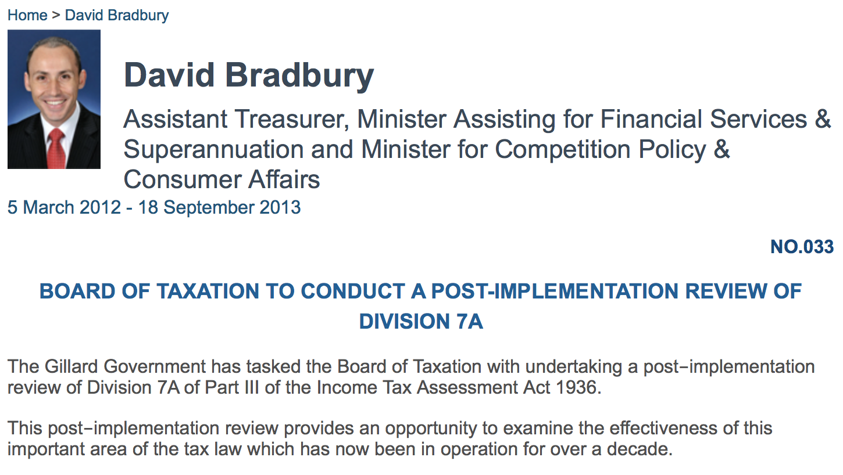

Change in Government and a new Assistant Treasurer hears the same complaints about Division 7A from tax practitioners, and so the new Assistant Treasurer extends the scope and time frame of the Board of Tax review.

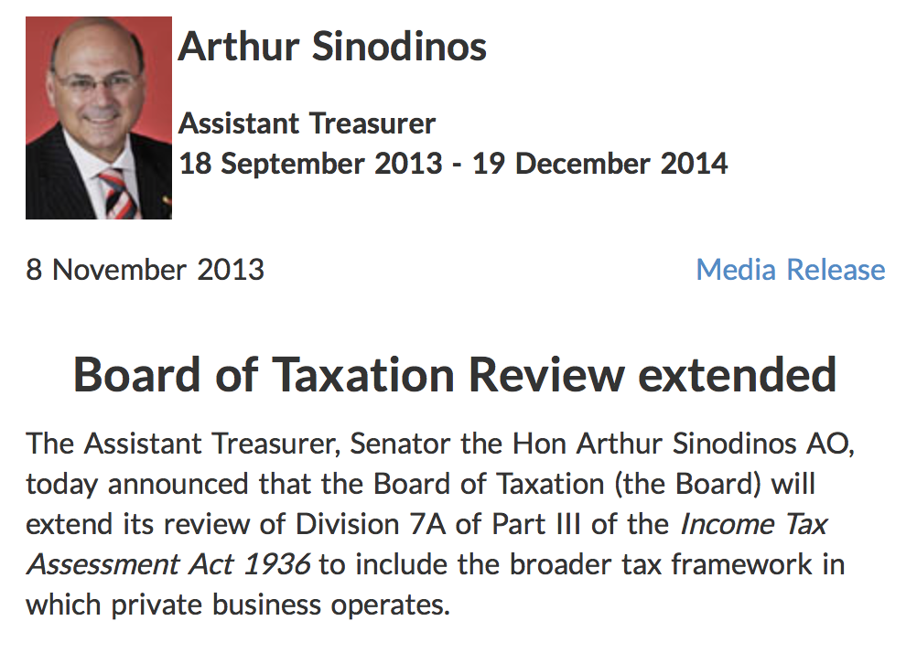
The Board of Tax is a well-run organisation and they provide the Government a report, with many substantial changes that the tax paying community agree will solve the confusion in late 2014.

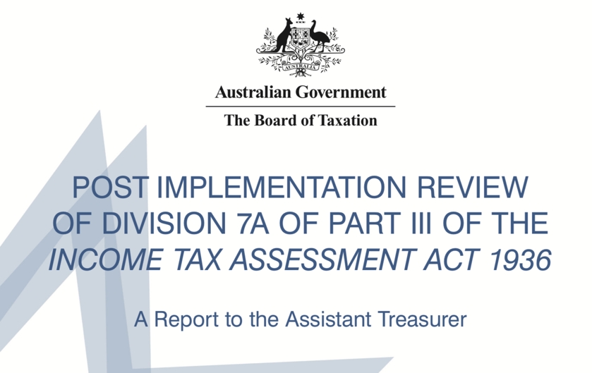
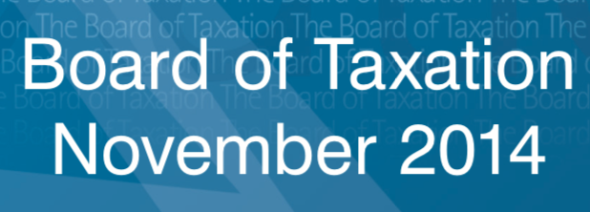

But we don’t see this report and all its recommendation until mid 2015, when another Assistant Treasurer, releases the report, and defer it. He announces he has forwarded the report to the Treasury to be considered in a broader review of the entire tax system.

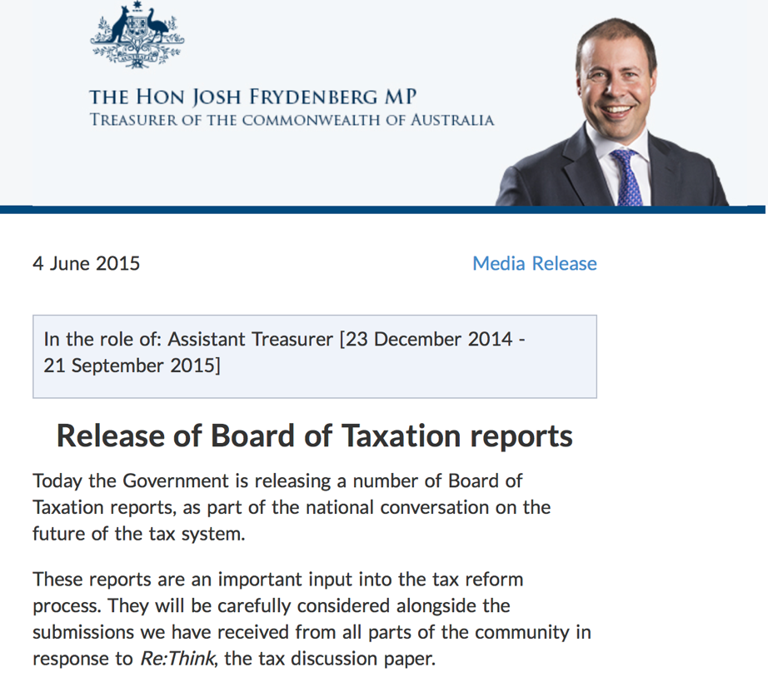

With the folding of the review, in the 2016/17 Budget in May 2016, an announcement was made that the changes in the Board of Tax report would be made, but not for over two years, in 1 July 2018.

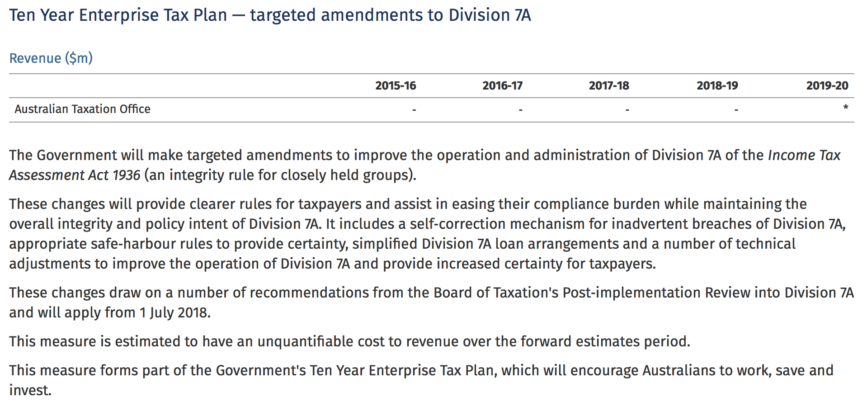

And then we heard nothing (a classic “go slow on what you don’t like” move). But we kept reminding them of the promise and in May 2018 they reconfirmed the promise to do something, but now whatever it is it will happen from 1 July 2019.

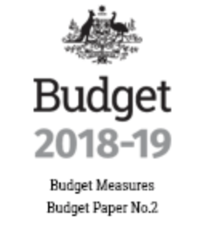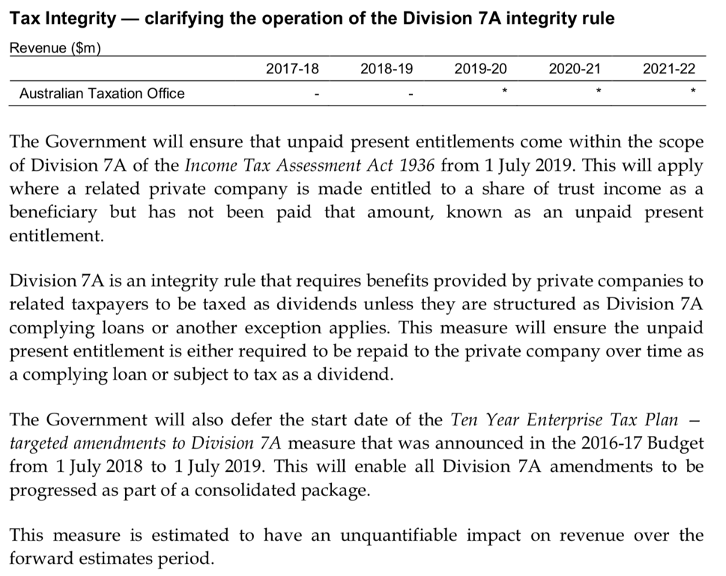

But in October 2018, the first crack in the wall of not changing Division 7A occurred in over 8 years. The Treasury released a Consultation paper indicating the changes that are proposed to be made on 1 July 2019.

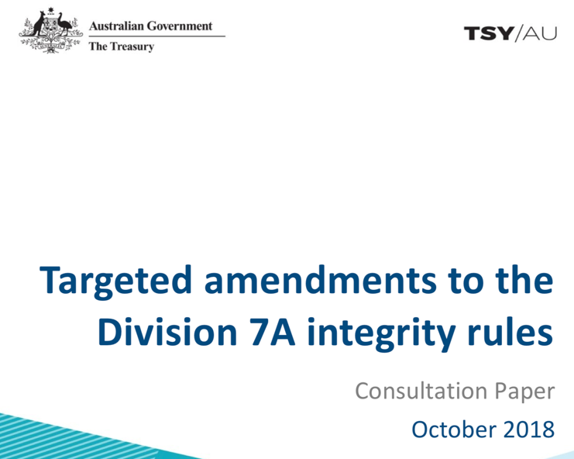

Most of the best changes recommended by the Board of Tax were now ignored, and numerous other crazy ideas (penalising taxpayers with loans that were grandfathered back in 1997 by ungrandfathering them 25 year later – insanity) were added making any change much less palatable than was recommended all those years ago. But we were still hanging on to the fact that changes to Division 7A will apply from 1 July 2019.

Until the Budget in April 2019. With only weeks before the changes were to apply and the Treasury only having had 5 years to write the policy and consult on it, the Government defers any change for another 12 months.
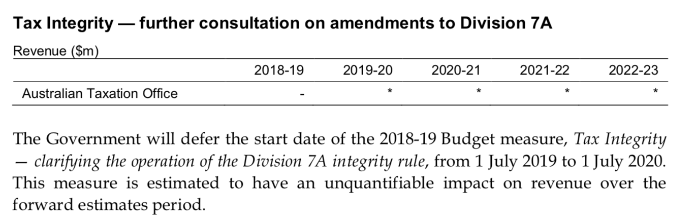

Three budget announcements over 4 years, three press releases, one Board of Tax report and one (pretty crazy) consultation paper. Can we please just make the changes as proposed in the original Board of Tax Report?

