17th December 2019

Australia’s interest rates have been reduced too low and for too long now.

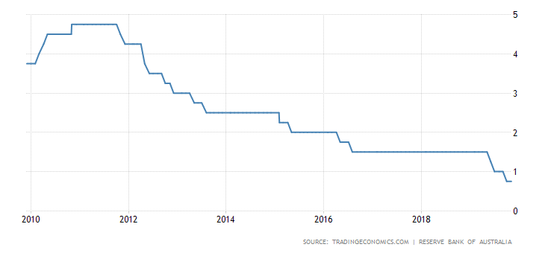
As at 15th December 2019 - Graph taken from https://tradingeconomics.com/australia/interest-rate

These extraordinary low interest rates are preventing many older Australians reaching their full potential. As they age they now struggle to meet basic living costs.
A direct result of a deliberately reducing income isolates residents within our own community.
It has got to the point where older people are being prevented from participating in society.

Take for example the Single Age or Disability pension rate:
SINGLE AGED or DISABILITY PENSION RATE for 2018/19
4 Oct. 2018 $915.68 per fortnight
4 April 2019 $926.20
$10.52 x 13 = $136.76 TOTAL increase for this 6 months.
Or put another way, 10.52 divided by 915.68 x 100 equals a 1.15% rise

4 April 2019 $926.20 per fortnight
3 Oct. 2019 $932.37
$6.17 x 13 = $80.21 TOTAL increase for this 6 months.
Or put another way, 6.17 divided by 926.20 x 100 equals a 0.67% rise
Dates and rates supplied by Centrelink.

The RBA cash rate recently dropped 3 times in 6 months.
So where do things sit at present?
Single aged and disability pensioners on full benefits had their pension increase reduced by almost half on the 4th April this year. It only amounted to a 0.67% rise which is even below the current 0.75% RBA rate.

With an eroding pension increase of just 0.67 percent, how are these people meant to meet regular increases for such things as water (sewage, fixed water charge and usage charge all up 3.5% next year), electricity, insurance, council rates, phone, internet, medical, home maintenance, car (RACT figures: petrol $1.40 12/1/2019 currently up to $1.65 a litre), food and so on? And,
How are communities meant to comply with increases through Strata Titles Acts which were written years ago when monetary policy was totally different?
In real terms as a result of these decreases, pensions are effectively being reduced because everything else is increasing in dollar terms.

We have never seen interest rates going down for so long and the cash rate has never been below 1% previously, let alone staring at zero percent.
And respected Trading Economics says,
“…Looking forward, we estimate Interest Rate in Australia to stand at 0.25 in 12 months’ time.”

Further, not only have Age or DSP recipients suffered reduced increases in pension entitlements, those with any money in savings accounts have also suffered significant and unstainable lower returns because the government tells the banks they must.

People are being forced to cancel essentials for which they would normally pay someone else. They are being forced to try and do more for themselves, but in doing so they have to give up voluntary service time and cannot support organisations that they normally would.

The Governor of the Reserve Bank has indicated there is room to even lower the cash rate further then they will monitor what happens. It is policy on the run and it is not working.
The RBA cash rate is predicted to drop to 0.25 next year (2020) so the outlook is horribly bleak for most people in this situation. What is worse older Australians on pensions cannot escape it.

This is not a fair go. There needs to be a considerable rise in our age and disability pensions and it needs to happen immediately.

