MSD 2021-2022 Budget Submission
Merck Sharp & Dohme (Australia) Pty Ltd, December 2020

SUMMARY
MSD is passionate about improving the health of Australians, and has a long history of working with the Government to ensure that Australians have access to the latest innovations in medicines and vaccines.
The World Health Organisation has described antimicrobial resistance (AMR) as one of the key global health issues facing our generation. If no action is taken, it has been estimated that by 2050, 10 million people could die every year as a result of AMR, exceeding the number of deaths caused by cancer (8.2 million). The COVID-19 pandemic has highlighted the critical importance of health security, and of investing in pandemic preparedness. AMR is described by many organisations as a silent pandemic that is happening now.
Australian Government’s national leadership on this issue is evidenced by a $22.5 million commitment to address priorities identified in Australia’s National Antimicrobial Resistance Strategy – 2020 & Beyond, as well as the appointment of Minister for the Environment Sussan Ley to the first One Health Global Leaders Group on Antimicrobial Resistance. MSD welcomes these developments, and notes that additional funding will be required to ensure that Australians have continued access to novel antimicrobials. We are therefore proposing the establishment of a new pilot fund for these indispensable, life-saving medicines.
MSD also supports the pre-budget submission by the Australian Antimicrobial Resistance Network (AAMRNet).
Recommendation for a Pilot Fund FOR NOVEL ANTIMICROBIALS
Investing in an innovative, three-year pilot for funding up to five novel antimicrobials to help address the looming crisis posed by AMR, would further demonstrate Australia’s global policy leadership following its world-leading response to COVID-19. The pilot would also ensure equity of access to crucial life-savings drugs not widely available in Australia.
Features of the Pilot
- A three-year pilot, using the de-linked model currently being piloted in the United Kingdom, whereby reimbursement of novel antimicrobials is not linked to the volume of antimicrobials sold.
- Up to five novel antimicrobials selected to participate, targeting priority pathogens, to be used in accordance with antimicrobial stewardship guidelines.
- A pragmatic approach to valuation of the participating drugs.
Estimated Cost of the Pilot
- A pragmatic valuation approach shows that funding one drug would require in the order of up to $10M per year.
- A pilot program for 5 drugs would require an investment of up to $50M per year, for three years.
Benefits of the Pilot
- Short term: up to five novel antimicrobials, targeting priority pathogens, would be available for clinicians to prescribe to the right patient at the right time, in accordance with clinical guidelines rather than hospital budgets.
- Long term: the pilot would encourage investment in research and development, and would also set an example for other countries to establish similar programs.

Antimicrobial Resistance – A Growing Threat

What is AMR?
Antimicrobials are medicines used to treat and prevent infectious diseases caused by pathogens such as bacteria, viruses, fungi and parasites. Antibiotics, which are used to treat bacterial infections, are one of the most important types of antimicrobials. AMR occurs when a pathogen evolves into a ‘superbug’, to survive antimicrobial treatment. While such evolution is inevitable, AMR is developing more quickly due to the inappropriate use of antimicrobials. Action is needed to slow down the development and spread of AMR so that the antimicrobials we have continue to work for as long as possible. This should include investment in new antimicrobials together with clinical guidelines for how and when they can be used.

Why is AMR a problem?
As explained by the Australian Group on Antimicrobial Resistance (AGAR): “AMR is a risk to patient safety because it reduces the range of antimicrobials available to treat infections. It also increases morbidity and mortality associated with infections caused by multidrug-resistant organisms. AMR may limit future capacity to perform medical procedures such as organ transplantation, cancer chemotherapy, diabetes management and major surgery because of a lack of effective antimicrobials.”
AMR is responsible for an estimated 25,000 deaths per year in the EU, and the loss to EU health care and productivity as a result of AMR is estimated at €1.5 billion annually. The impact of AMR in Australia has not been quantified in these terms, however adjusting for population and currency this would equate to roughly 1,250 deaths and a $120 million loss to healthcare and productivity annually in Australia. A recent Australian study has found that on any given day, one in every ten acute adult inpatients in has at least one hospital acquired infection.
AMR can be slowed down through the judicious use of antimicrobials, a practice known as Antimicrobial Stewardship (AMS), but it cannot be stopped. New antibiotics are urgently needed to address growing resistance, however there are relatively few in development. Over the past two decades, there has been a significant decline in the number of companies conducting antimicrobial research and development. Today, only a handful of pharmaceutical companies, including MSD, have antibiotics in clinical development.

Challenges to developing new antimicrobials
The market for novel antimicrobials is broken. In Australia there are multiple challenges facing companies that invest in the development of novel antimicrobials:
- Uptake of novel antimicrobials is slow as they are typically held in reserve by healthcare practitioners until resistance has emerged to older treatments. This immediately limits the usage of a new product and the recouping of any research and development costs.
- There is no national reimbursement system for antimicrobials in Australia. They are purchased by individual hospitals, which have highly constrained budgets.
- The need for hospitals to manage their budgets means that the use of novel antimicrobials can be discouraged, even when they may be a more appropriate treatment for a patient than a generic antimicrobial.
- Novel antimicrobials are generally undervalued by reimbursement systems relative to the benefits they bring to society as indispensable, life-saving drugs, because of the low cost comparator, which is often generic.

Access to novel antimicrobials in Australia is limited
Of the 19 antimicrobials considered to be novel which have been registered in Europe and/or the US in the last decade, only 3 have been registered in Australia, as the cost of entering the market is often greater than the potential returns (see Appendix A for details). Clinicians are desperate to access these therapies for cases where patients who have multi-drug-resistant infections do not respond to the available options.

AN AUSTRALIAN PILOT WOULD SHOW GLOBAL LEADERSHIP

New approaches to funding antibiotics in the UK and Sweden
In order to stimulate the ‘broken market’ a new approach to funding is required. The UK recently launched a pilot using a ‘de-linked’ model, in which companies are paid an annual subscription fee to supply as much or as little of an antimicrobial as required. This results in more predictable revenue for the manufacturer, and coverage for the health system in the event of disease outbreaks. In other words, companies are paid for antimicrobials based on their expected value to the health system, as opposed to the actual volume used.
In Sweden a new reimbursement model is being piloted which aims to ensure the availability of new antibiotics of special medical value via shared payments from national and regional governments. Pharmaceutical companies that enter into contracts and fulfil the requirements for availability will be guaranteed a certain annual income at the national level. Regions will continue to buy and pay as usual for the products. If the actual income from regions to the companies is lower than the guaranteed income for a given year, the difference will be paid from the national level. If, on the other hand, revenue from the sales exceeds the guaranteed level for a given year, the company receives 10% of the value of the guaranteed annual compensation, for fulfilling availability requirements.
Elements of both these new approaches could be incorporated into an Australian pilot, such as the UK’s de-linked model, and Sweden’s cost-sharing arrangements between national and regional governments.

Principles of the proposed pilot
In order to limit the innovative fund concept to a workable pilot, the following principles are proposed:
- The pilot should use the de-linked model whereby an annual subscription fee is paid regardless of the amount of antimicrobial used.
- The pilot should be jointly supported by the Commonwealth and State Governments. The National Blood Authority provides an example of a joint funding model.
- The pilot should be reserved for up to five drugs which treat organisms for which the impact of resistance is high in the hospital setting. For example, carbapenem-resistant Pseudomonas aeruginosa is a priority 1 pathogen according the World Health Organisation, and is a major emerging AMR threat in Australia. Novel antibiotics to treat this pathogen are available, but they are expensive compared to cheaper generic options, so can be under-used, even when they are the most appropriate choice.
- The pilot should ensure equity of access to the chosen drugs across metropolitan, rural and remote Australia, in all states and territories.
- The pilot should support the AMS principle of using the right drug for the right patient, for the right organisms, at the right dose, at the right time, so that usage is always based on clinical need and appropriate use rather than the cost of an antibiotic.
- The pilot should recognise the broader social value of making novel antibiotics available, while at the same time preserving their use according to AMS principles.
- The pilot should act as a signal to industry that the government is willing to create a stable market for novel antimicrobials.
- The pilot will establish Australia as an AMR policy leader by providing an example for other countries to follow to help address the growing, global threat of AMR.

How the pilot would work
MSD is proposing a three-year pilot which would fund up to five novel antimicrobials, structured as shown in Figure 1.
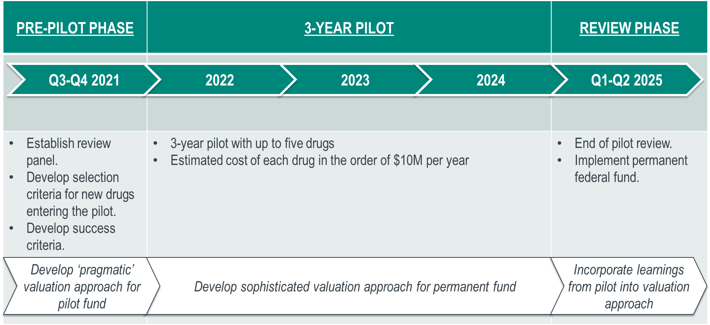
Figure 1 – Pilot Structure
- A pre-pilot phase would establish:
  - a review panel
  - selection criteria for drugs entering the pilot
  - a ‘pragmatic’ valuation approach for the drugs entering the pilot
  - success criteria for the pilot
  - surveillance and measurement requirements
- Sponsors would apply to enter the pilot, and the review panel would select up to five drugs according to the agreed selection criteria, for example:
  - the drug targets a priority pathogen
  - susceptibility rates, resistance trends and real world evidence for the drug are available
  - the drug has the ability to overcome mechanisms of resistance
  - the drug is a new class or an extension of existing class
  - the sponsoring company has the ability to engage with the process over time
  - the sponsoring company can meet social responsibility and stewardship commitments
- For the chosen drugs, a set fee would be paid annually to the sponsor. The fee would be determined based on a pragmatic approach to valuing the drug (see the next section – note that the fee may be different for each drug chosen). The company would ensure that sufficient drug is made available to manage all anticipated infections within the established framework.
- The pilot would run for three years. During this time a more sophisticated valuation approach for the permanent fund would be developed.
- A post-pilot review would be held, to inform the establishment of a permanent fund.
The short term benefit of this pilot is that up to five novel antibiotics would be available for clinicians to prescribe to the right patient at the right time, in accordance with clinical guidelines rather than hospital budgets.
The long term benefit of this pilot is that it would send a strong signal to the market that there is a reliable return for investing in research and development decisions, and would also set an example for other countries to do the same.

A Pragmatic Valuation Approach
The UK has already spent several years developing a workable model to determine the expected value which takes into account their full value to society, including transmission value, insurance value, diversity value, enablement value, novel action value and spectrum value. This work is ongoing, as they are trying to establish a balance between the difficulty of the task, the complexity of the modelling required, and the use of expert opinion.
The purpose of this Australian pilot is not to develop an HTA approach to valuing novel antimicrobials, but rather to provide an opportunity for Government, clinicians and industry to work together on practical solutions for a pressing health issue. A simple, pragmatic approach should be taken to determining a value for the pilot, which would enable a pilot to commence whilst a more sophisticated valuation approach could be developed over the three years of the pilot.
A recent report which reviews the available data on the burden of AMR estimates that $10M per year would be appropriate to fund a novel antimicrobial for the pilot (see Appendix B).

ABOUT MSD
For more than a century, MSD, a leading global biopharmaceutical company, has been inventing for life, bringing forward medicines and vaccines for the world’s most challenging diseases. MSD is a trade name of Merck & Co., Inc., with headquarters in Kenilworth, N.J., U.S.A. Through our prescription medicines, vaccines, biologic therapies and animal health products, we work with customers and operate in more than 140 countries to deliver innovative health solutions. We also demonstrate our commitment to increasing access to health care through far-reaching policies, programs and partnerships. Today, MSD continues to be at the forefront of research to advance the prevention and treatment of diseases that threaten people and communities around the world - including cancer, cardio-metabolic diseases, emerging animal diseases, Alzheimer’s disease and infectious diseases including HIV and Ebola.
MSD is one of the few remaining large pharmaceutical companies investing in antimicrobial research and development. As part of our global commitment to tackling AMR we have contributed USD$100 million to the AMR Action Fund: a coalition of over 20 biopharmaceutical companies which aims to bring 2-4 new antimicrobials to market by 2030. Our CEO Kenneth Frazier has been appointed to the first One Health Global Leaders Group on Antimicrobial Resistance, alongside Minister for the Environment Sussan Ley. MSD has a footprint in both human and animal health, which uniquely positions us to contribute to the One Health approach in Australia’s National Antimicrobial Resistance Strategy – 2020 and Beyond. In Australia our investment in research and development includes 158 clinical trials, with 2,950 participants.
For more information visit www.msd-australia.com.au

For further information in relation to this submission please contact:
Megan Bohensky, Head, Policy & Access Strategy, MSD
26 Talavera Road, Macquarie Park, NSW 2113
Telephone: +61 414 795 031
Email: megan.bohensky@msd.com

Appendix A – ACCESS TO Novel ANTIMICROBIALS in australia
The following table shows that of the 19 antimicrobials considered to be novel which have been registered in Europe and/or the US in the last decade, only 3 have been registered in Australia.
 | Antibacterial^{1,2} | AMR activity (Enzyme)^{2,4,5,6} | Registered in USA¹ | Registered in Europe^{1, 7} | Registered in Australia³
1 | Fidaxomicin | N/A | 2011 | 2011 | 2013
2 | Bedaquiline | Mycobacterium tuberculosis | 2012 | 2014 | Not Registered
3 | Dalbavancin | - | 2014 | 2015 | Not Registered
4 | Oritavancin | - | 2014 | 2015 | Not Registered
5 | Tedizolid phosphate | - | 2014 | 2015 | Not Registered
6 | Finafloxacin | - | 2014 | Not Registered | Not Registered
7 | Delaminid | - | Not registered | 2014 | Not Registered
8 | Ceftolozane/ tazobactam | Yes (ESBLs; P. aeruginosa) | 2014 | 2015 | 2015
9 | Ceftazidime/ avibactam | Yes (ESBLs, KPC; OXA-48; P. aeruginosa) | 2015 | 2016 | 2019
10 | Delafloxacin | - | 2017 | 2019 | Not registered
11 | Meropenem/ vaborbactam | Yes (ESBLs; KPC) | 2017 | 2018 | Not Registered
12 | Plazomicin | Yes (ESBLs; KPC; MBL – variable; OXA-48; P. aeruginosa – variable) | 2018 | Not Registered (Authorised 2018, Withdrawn 2020) | Not Registered
13 | Eravacycline | Yes (ESBLs; KPC; MBL; OXA-48; S. maltophilia) | 2018 | 2018 | Not Registered
14 | Omadacycline | - | 2018 | Not Registered  (Withdrawn 2019) | Not Registered
15 | Sarecycline | - | 2018 | Not Registered | Not Registered
16 | Pretomanid | Yes; XDR M. tuberculosis in combination | 2019 | 2020 | Not Registered
17 | Lefamulin |  | 2019 | 2020 | Not Registered
18 | Cefiderocol | Yes (ESBLs; KPC; MBL - variable; OXA-48; P. aeruginosa; A. baumannii; S. maltophilia) | 2019 | 2020 | Not Registered
19 | Imipenem/ relebactam | Yes (ESBLs; KPC; P. aeruginosa) | 2019 | 2020 | Not Registered
Note: agents with activity against priority pathogens are shown in bold; includes ‘Urgent’ and ‘Serious’ threats in the USA and “Critical’ and ‘High’ based on WHO ratings for R&D.
¹ Butler MS, Paterson DL. Antibiotics in the clinical pipeline in October 2019. J Antibiot (Tokyo). 2020 Jun;73(6):329-364. doi: 10.1038/s41429-020-0291-8. Epub 2020 Mar 10. PMID: 32152527; PMCID: PMC7223789.
² Paterson DL, Isler B, Stewart A. New treatment options for multiresistant gram negatives. Curr Opin Infect Dis. 2020 Apr;33(2):214-223. doi: 10.1097/QCO.0000000000000627. PMID: 32068644.
³ TGA
⁴ Doi, Y. Treatment Options for Carbapenem-resistant Gram-negative Bacterial Infections 2019:69 CID
⁵ 2019 AR Treats Report https://www.cdc.gov/drugresistance/biggest-threats.html ; https://www.cdc.gov/drugresistance/pdf/threats-report/2019-ar-threats-report-508.pdf
⁶ https://www.who.int/medicines/publications/WHO-PPL-Short_Summary_25Feb-ET_NM_WHO.pdf
⁷ Rex https://amr.solutions/2020/09/07/new-antibiotics-are-not-being-registered-or-sold-in-europe-in-a-timely-manner/

Fidaxomicin: https://www.ema.europa.eu/en/medicines/human/EPAR/dificlir
Bedaquiline: https://www.ema.europa.eu/en/medicines/human/EPAR/sirturo
Dalbavancin: https://www.ema.europa.eu/en/medicines/human/EPAR/xydalba
Oritavancin: https://www.ema.europa.eu/en/medicines/human/EPAR/orbactiv
Tedizolid phosphate: https://www.ema.europa.eu/en/medicines/human/EPAR/sivextro
Delamanid: https://www.ema.europa.eu/en/medicines/human/EPAR/deltyba
Ceftolozane/tazobactam: https://www.ema.europa.eu/en/medicines/human/EPAR/zerbaxa
Ceftazidime/avibactam: https://www.ema.europa.eu/en/medicines/human/EPAR/zavicefta
Delafloxacin: https://www.ema.europa.eu/en/medicines/human/EPAR/quofenix
Meropenem/vaborbactam: https://www.ema.europa.eu/en/medicines/human/EPAR/vaborem
Plazomicin: https://www.ema.europa.eu/en/medicines/human/withdrawn-applications/zemdri
Eravacycline: https://www.ema.europa.eu/en/medicines/human/EPAR/xerava
Omadacycline: https://www.ema.europa.eu/en/medicines/human/withdrawn-applications/nuzyra
Pretomanid: https://www.ema.europa.eu/en/medicines/human/EPAR/pretomanid-fgk
Cefiderocol: https://www.ema.europa.eu/en/medicines/human/EPAR/fetcroja
Imipenem/relebactam: https://www.ema.europa.eu/en/medicines/human/EPAR/recarbrio

Appendix B – PRAGMATIC Valuation Approach for Pilot Fund for Novel ANTIMICROBIALS
This extract is from a report by Health Technology Analysts entitled Federal Fund for Novel Antimicrobials (2020).
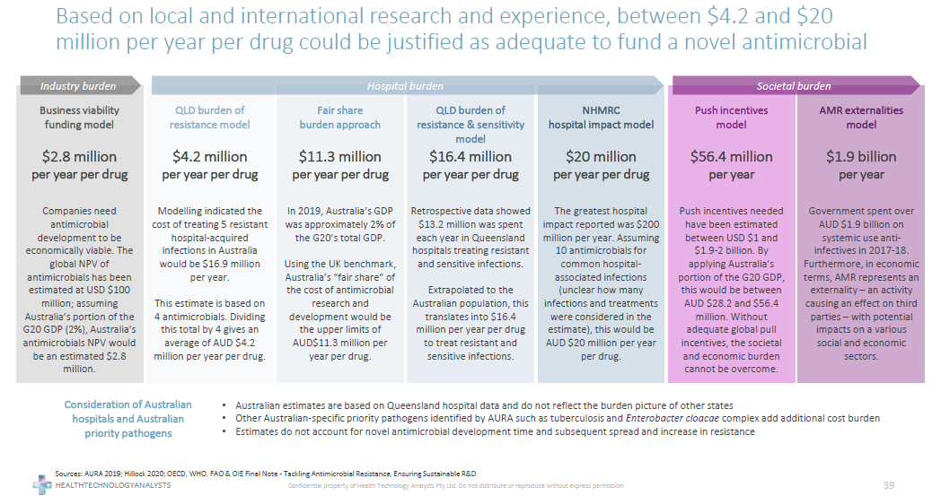

Jim O’Neill, 2014, Review on Antimicrobial Resistance. Antimicrobial Resistance: Tackling a Crisis for the Health and Wealth of Nations
Jim O’Neill, 2014, Review on Antimicrobial Resistance. Antimicrobial Resistance: Tackling a Crisis for the Health and Wealth of Nations
Australian Group on Antimicrobial Resistance; Sepsis Outcome Programs, 2018 Report
European Medicines Agency, European Centre for Disease Prevention and Control, 2009, Joint technical report: The bacterial challenge: time to react, viewed 16 December 2019 <https://www.ecdc.europa.eu/sites/portal/files/media/en/publications/Publications/0909_TER_The_Bacterial_Challenge_Time_to_React.pdf>
Philip L. Russo et.al 2019, The prevalence of healthcare associated infections among adult inpatients at nineteen large Australian acute-care public hospitals: a point prevalence survey, Antimicrobial Resistance and Infection Control
Department of Health and Agriculture, Responding to the Threat of Antimicrobial Resistance: Australia’s First National Antimicrobial Resistance Strategy 2015-2019
Bhatti T et al 2018, A Perspective on Incentives for Novel Inpatient Antibiotics: No One-Size-Fits-All, Journal of Law, Medicine and Ethics, p60
Neri, M., Hampson, G., Henshall, C., and Towse, A., 2019. HTA and payment mechanisms for new drugs to tackle AMR. OHE Research Paper, London: Office of Health Economics
World-first scheme underway to tackle AMR and protect UK patients - GOV.UK (www.gov.uk)
Neri, M., Hampson, G., Henshall, C., and Towse, A., 2019. HTA and payment mechanisms for new drugs to tackle AMR. OHE Research Paper, London: Office of Health Economics
Availability of antibiotics - The Public Health Agency of Sweden (folkhalsomyndigheten.se)
https://www.who.int/medicines/publications/global-priority-list-antibiotic-resistant-bacteria/en/
Williamson, Deborah. A., Howden, Benjamin P., Paterson, David L., 2019, The risk of resistance: what are the major antimicrobial resistance threats facing Australia?, Medical Journal of Australia
Rothery, C., Woods, B., Schmitt, L., Claxton, K., Palmer, S., Schulper, M., 2018, Framework for Value Assessment of New Antimicrobials. Implications of alternative funding arrangements for NICE Appraisal. EEPRU, Policy Research Unit in Economic Evaluation of Health &Care Interventions, viewed 17 December 2019 <http://www.eepru.org.uk/wp-content/uploads/2017/11/eepru-report-amr-oct-2018-059.pdf>

