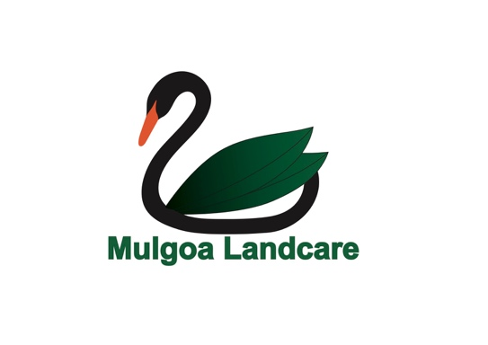

Pre-Budget Proposal

Electorate: Lindsay
Objective: Complete the Cumberland Conservation Corridor which will improve ecological connectivity and reduce the Penrith ‘Heat Island Effect’.

The Mulgoa Valley Landcare Group is a member organisation of the Cumberland Conservation Network (CCN).

The Mulgoa Landcare Group has been closely involved in previous election cycle campaigns to create a connected Biodiversity Corridor through Western Sydney to alleviate impacts of the immense ecological impacts created by urban, commercial and infrastructure developments in our region. Until the most recent election of 2019, $50 Million had been allocated in the previous 4 election cycles to create this corridor. This has been a community campaign extending over the past 20 years.

Since 2019, there has been no investment by the Federal Government in projects that might balance the impacts of the catalyst, the Western Sydney Airport, and all the subsequent developments that have evolved as a result of the new airport. As a consequence, the vegetation communities of Western Sydney are now listed as critically endangered and they have become so highly fragmented that they are considered ‘functionally extinct’. And yet – our appetite to ‘clear more’ is insatiable. This has resulted in the loss of animal species that were once common in our region – and has also contributed to the decline in foraging and habitat opportunities of critically endangered migratory/nomadic species that rely on habitat on the Cumberland to complete their migratory journeys (eg the Swift parrot and the Grey Headed Flying Fox) the Cumberland Plain.

In this current term, we have yet to see any meaningful contribution that might ‘balance’ the impacts of the development juggernaut that exists on the Cumberland Plain. In fact, this unmitigated development is making life ‘unliveable’ for our native wildlife and humans alike, with Penrith now identified by the UN as a ‘climate Change hot Spot’ with our soaring temperatures and our unabated desire to concrete all surfaces in Western Sydney. With Mascot achieving the highest temperature on Australia Day (42 degrees) and located conveniently ON the coast – we wonder what temperature will be recorded at Badgery’s Creek in 5 years from now with an additional 11 square kilometres of hard stand poured to create just one runway for the Western Sydney Airport?

All this and no meaningful contribution from the Federal Government to allow existing residents the opportunity to enjoy the amenity in this region? This will, without doubt, be the big question for the electorates of Western Sydney as we move toward the election on 2022 – will we be able to live in Sydney given the current heat impacts and the lack of investment in our natural environment?

We invite the treasury department to consider this issue as we propose a $50 Million funding package for the completion of the Cumberland Conservation Corridor. This will require the re-instatement of the CCC Reference Group (previously convened by the Federal Environment Department), the acquisition of essential property links and at the recognition that far more is required to prevent species extinction, ecological destruction and unliveable heat consequences for existing residents.

Thank you for the opportunity to remind the Federal Government that it has failed to consider Western Sydney holistically – and the community discontent with mounting ‘construction burnout’ will be a key issue for residents of this region in coming years.

Regards
Lisa Harrold
President
Mulgoa Valley Landcare Group Inc.

