**MULTIPLE SCLEROSIS AUSTRALIA**

Pre-budget submission for the 2021-22 Federal Budget

28 January 2020

**Rohan Greenland**

**Chief Executive Officer**

**Introduction**

Multiple Sclerosis Australia (MS Australia) is pleased to make this pre-budget submission to the Australian Government consultation for the 2021-2022 Budget. The focus of the comments provided in this submission are on key areas that will impact on people affected by multiple sclerosis (MS). Many of these issues are set out in our three Roadmaps ([A Roadmap to Defeat MS in Australia, a Roadmap to Support People with MS Living with Disability and A Roadmap to Support People Ageing with MS](https://www.msaustralia.org.au/about-msa/2019-election-commitments-make-our-stories-matter)) that were launched by the Prime Minister, the Hon Scott Morrison MP, in November 2018.

People with MS have two fundamental needs:

1. Better treatments, prevention and ultimately, a cure for the disease - there is no known cause or single cure, but a cure could well be within reach.

2. Improved support for the management and care of MS - the 2021-22 Budget provides an opportunity for this generation of political leaders and decision-makers to provide improved support for the management and care of MS, through systemic improvements to the health care, disability care and aged care sectors.

MS Australia seeks commitments from the Australian Government through the 2021-22 Federal Budget to:

(i) Prevent and ultimately defeat MS in Australia through a significant investment in research funding for better treatments, prevention and ultimately a cure for MS

(ii) Improve support for people with MS living with disability

(iii) Support people ageing with MS

A key focus of improved support for the management and care of MS is to keep people with MS at home where they are safer, out of aged care homes, where possible supported at work, and with interventions that will ensure a high quality of life. MS Australia believes that this focus is fiscally efficient, ultimately making economic savings and providing a boost for the health, disability and aged care sectors, especially in job creation.

**The economic and personal cost of MS – some facts and figures[1]**





**Summary of recommendations**

**MS Australia recommends:**

1. **An investment of $35 million into research funding, with matched funding of $20 million, is made for better treatments, prevention and ultimately a cure for MS aligned to the specific programs set out in the Implementation Plan for A Roadmap to Defeat Multiple Sclerosis in Australia**

**2.1 The Health Care Homes program is funded to continue beyond June 2021**

**2.2 All people living with MS in Australia should be able to automatically access the Health Care Homes program**

**3.1 An additional 50,000 Home Care Packages be funded**

**3.2 Establishment of a funded National Assistive Technology Program**

**4. An increase in the availability of specialist disability accommodation**

**5. The creation of a publication aimed at explaining MS to primary school-aged children in Australia, with an investment of $100,000**

**6. The establishment of an evidence-based model of care for MS in Australia, with an investment of $950,000**

**7. The development and implementation of a new National Carer Strategy.**

1. **Research into MS**

A significant investment in research funding is required to prevent and ultimately defeat MS in Australia. This will be achieved through research, with the goals of providing better treatments for those living with MS, prevention of MS in those at risk and ultimately a cure for the disease. The aims of MS Australia’s proposed program of research align perfectly with the priorities of the Medical Research Future Fund:

**1. Build research capability and capacity:** through fellowships and clinician-researcher grants;

**2. Harness and improve collaborative research efforts through infrastructure:** a

nationally funded infrastructure for deeply characterised patient cohorts, interlinking

clinical and patient reported data and biobanks, available to all researchers; and

**3. Clinical trials and clinical trial enabling infrastructure:** to accelerate new treatments and ultimately find a cure for and prevention of MS.

MS Australia has the core capabilities, expertise and relationships with MS researchers both nationally and globally, to provide comprehensive and cohesive oversight and implementation to a wide scale research plan as outlined in the *Implementation Plan for A Roadmap to Defeat Multiple Sclerosis in Australia*.

**MS Australia recommends that $35 million be provided to implement the Roadmap, with an additional $20 million provided from matched sources.** This will enable MS Australia to implement the following priorities with the goal of Stopping and Reversing MS within ten years:

* Innovative pre-clinical and clinical research studies on nerve repair and protection to minimise the impact of all forms of MS ($20 million).
* Provision of competitive and prestigious researcher programs to retain, sustain and grow the pool of high-quality researchers in Australia; individuals who have excelled or show potential to excel in MS research ($12 million).
* Develop and improve infrastructure aimed at optimising personalised management and prevention of MS ($5.5 million).
* Improve the secondary prevention of MS by addressing modifiable lifestyle risk factors ($3 million).
* Support national clinical trials and Australian arms of international clinical trials ($8 million).
* Support and implement clinical studies that aim to prevent MS ($2.5 million).
* Expand access to Autologous Haematopoietic Stem Cell Transplant (AHSCT) for MS ($2 million).
* Investment to establish, build and audit national care pathways ($2 million).

Further details of the activities can be found in the attached *Implementation Plan for A Roadmap to Defeat Multiple Sclerosis in Australia*.

1. **Health Care**

**Health Care Homes**

A Health Care Home is a general practice or an Aboriginal Community Controlled Health Service (ACCHS) that coordinates care for patients with chronic and complex conditions.[2]

In December 2018, the Government announced the extension of the Health Care Homes program for an additional eighteen months to 30 June 2021.

**It is essential that the Health Care Homes program is funded in the 2021-22 Budget to continue beyond June 2021** with a full national roll out, to ensure participants receive coordinated and innovative patient-centred care for their chronic and complex health conditions.

Given the complex and chronic nature of MS, MS Australia further submits that **all people living with MS in Australia should be able to automatically access the Health Care Homes** program.

1. **Aged care**
   1. **Home Care Packages**

MS Australia wants to ensure that people with MS are adequately supported to stay at home for as long as possible and only be recommended for residential care when every other possible avenue of care and support has been exhausted. Assisting people to remain in their homes allows them to retain independence and stay connected to their community. This will also avoid admissions into residential care, often where their condition deteriorates rapidly.

In the current climate of COVID-19, keeping people in their homes also reduces exposure to COVID-19 infection and the subsequent health consequences. The delivery of further Home Care Packages will also provide a potential opportunity for rapid workforce expansion in this sector.

This necessitates investment in additional home care packages to alleviate long waiting lists. Announcements of additional packages in recent years (e.g. 10,000 in December 2018, 10,000 in February 2019 and another 10,000 in December 2020) have been inadequate and will never catch up to the growing demand and lengthening waiting lists.

As stated on page 161 of the interim Report of the Royal Commission into Aged Care Quality and Safety, “Given the extent of the pre-existing waiting list, it is clear that the additional Packages will not satisfy the current, and growing, demand for home care”.

**MS Australia recommends that at least an additional 50,000 Home Care Packages be funded** in the 2021-22 Budget to alleviate the long waiting lists and to ensure that those eligible wait no longer than three months for their Package to be activated.

* 1. **Assistive technology for older Australians**

Assistive technology (AT) plays a critical role in the lives of people with disability of all ages by facilitating independence and participation in everyday activities. Screen reading software, mobility aids, electronic communication devices and prosthetic aids are all examples of AT.

It is essential that older people with disability have access to the support they need to lead full and active lives. The NDIS is able to provide scheme participants with fully funded access to assistive technology, but the situation for those who are excluded from the scheme is very different. Older people with disability bear the brunt of this arrangement, as the age cut-off for eligibility for the NDIS is 65.

People who are excluded from the NDIS are commonly required to wait well over a year to access funding for AT. They are forced to self-fund part or all of the equipment they need, often at considerable expense and in some cases, they simply go without.

Provision of AT keeps people living their lives better – in work and at home, resulting in less demand on support systems.

**MS Australia recommends that the 2021-22 Budget prioritise the establishment of a funded National Assistive Technology Program** to meet the needs of people with disability who are excluded from the NDIS.

1. **Disability care**

**Young people living in residential aged care**

Many young people with disability live in aged care because there is nowhere else for them to live.

MS Australia welcomed the release by the Australian Government of the [Younger People in Residential Aged Care Strategy 2020-25](https://www.dss.gov.au/disability-and-carers/programmes-services/for-people-with-disability/younger-people-with-disability-in-residential-aged-care-initiative) and also the Government’s 2020-21 budget commitment of $10.6m to establish a national network of system coordinators to help younger people find age-appropriate housing, disability supports, health services and social supports that will allow them to live in the community, though more work needs to be done. MS Australia is especially concerned to ensure that interventions occur in those placement processes that will stop any more young people from being placed in residential aged care.

Improvements in recent years to the NDIS’s Specialist Disability Accommodation program are welcomed, but whilst the number of places is growing, the pace of growth is frustratingly slow.

**MS Australia recommends an increase in the availability of age-appropriate specialist disability accommodation (SDA)**, including support for incentive schemes to create more SDA as quickly as possible, potentially via seed funding to build on existing successful projects. It is believed that this investment will create jobs, with the potential to boost growth in regional areas and enable people living with a disability to live independently but near to their families, friends and community.

1. **Improving health literacy for young people**

MS is a disease that remains difficult for many in the community to understand. Despite the best efforts of the MS organisations in Australia and around the world, there is considerable lack of awareness and, at worst, misinformation about MS.

MS Australia agree with recent statements made by the Consumer Health Forum, that, “There is a need for a healthy information culture to overcome fake health news”.[3]

In light of this, and other recent statements by the Australian Medical Association regarding the need for improved health literacy[4] and the recommendation for a national health literacy strategy recommended by the Mitchell Institute’s [*Self-care for health: a national policy blueprint*](https://chf.org.au/civicrm/mailing/url?u=9527&qid=847335) launched by Minister Hunt in October 2020[5], **MS Australia recommends the creation of a publication aimed at explaining MS to primary school-aged children in Australia.**

This publication would be commissioned from an expert in childhood education, draw on existing older publications, and be informed by scientific experts in MS.

It is believed that by creating a resource which could be widely used in primary school libraries, facts about MS could be known and understood at an early age and this would make a significant contribution to the development of a healthy information culture in Australia.

The cost of this proposal is estimated to be $100,000.

1. **Develop and establish an evidence-based model of care for MS in Australia**

Currently there are no clinical guidelines available for the diagnosis and ongoing treatment of MS in Australia. For example, the National Health and Medical Research Council’s Australian Clinical Practice Guidelines[6] have no entry regarding MS and the material in each Primary Health Network’s information repositories about MS is at best minimal and patchy.

The evidence-based international consensus report, [*Brain health: time matters in multiple sclerosis*](http://www.msbrainhealth.org/report)*[7]*, states that, “Even in the early stages of MS, cognition, emotional well-being, quality of life, day-to-day activities and ability to work can be markedly affected by the damage occurring in the brain and spinal cord. As the disease progresses, increasing disability – such as difficulties in walking – imposes a heavy burden on people with MS and on their families. It also leads to substantial economic losses for society, owing to diminished working capacity.”[8]

In Australia, there is an urgent need for health professionals to speed up referral and diagnosis, intervene earlier to maximise lifelong brain health, improve the monitoring of disease activity and to act swiftly on the evidence of disease activity. It is also essential for health professionals to involve people with MS proactively in decision-making and in managing their disease and to encourage those in their care to play a fully informed, shared role in treatment decisions and to live a ‘brain-healthy’ lifestyle.

**MS Australia recommends the establishment of an evidence-based model of care for MS in Australia,** similar to that achieved by the UK’s NICE guidelines[9], to address the urgent needs described above. The development of the model of care would include consultation with and endorsement by MS specialist neurologists, MS specialist nurses and other health care professionals involved in the treatment and care of people living with MS.

In addition, this would enable the adoption of the international expert consensus standards for timely MS care developed by a panel of global MS specialist neurologists as set out in MS Brain Health consensus standards[10]. If implemented, these consensus standards have the potential to revolutionise the care of people with MS in Australia.

The cost of this proposal is estimated to be $950,000.

1. **Carers**

More than 1 in 10 Australians are informal carers.[11] Given the diversity in disease presentation and progression, people with MS require a broad and diverse range of support that often includes care delivered by family and friends. Recognition, acknowledgement and support for the vital role of carers is a crucial component of maintaining the carer in this role.

According to a [study commissioned by MS Australia and undertaken by KPMG](https://www.msaustralia.org.au/file/1548/download?token=x6lZhWZ4)[12] it was found that:

* 87% of people living with MS state they have someone (unpaid or informal) who is their main source of support.  For over half of people, this is a partner or spouse.  It was reported this person most often provided some sort of daily emotional support (69%), rather than physical assistance.
* 79% of carers report that caring has an impact on their emotional wellbeing.
* Family members and carers reported that services focused on the persons living with MS. They seek direct information about how to support the person, rather than receiving information second hand.  45% of carers are paying for health professionals support.
* Tailoring assistance to informal supporters is a key emerging service need.
* The majority of those who identified as carers reported that they were employed either full time (61%) or part time (16%) before they started providing care for someone living with MS.  When asked about their current employment status, only 30% of carers were employed full time and 11% part time.

##### As the National Disability Insurance Scheme implementation continues, and as changes are made to the aged care and health sectors, carers are even more critical. People with MS and their carers want useful information and advice, and together must navigate these sectors.

The previous National Carers Strategy lapsed in 2014, which is out-of-step with the states and territories. Current data gaps and a lack of research into carers and their role in health, mental health, aged care, disability care and the broader social capital of our communities has a substantial impact on the development of evidence-based policy, initiatives, service planning and provision. A new, stand-alone National Carer Strategy is essential to acknowledge and prepare for the growth in demand for informal carers – estimated in a study conducted in 2020 by [Deloitte Access Economic](https://www2.deloitte.com/au/en/pages/economics/articles/value-of-informal-care-2020.html)s to increase by 23% by 2030.[13]

**MS Australia recommends the development and implementation of a new National Carer Strategy.**

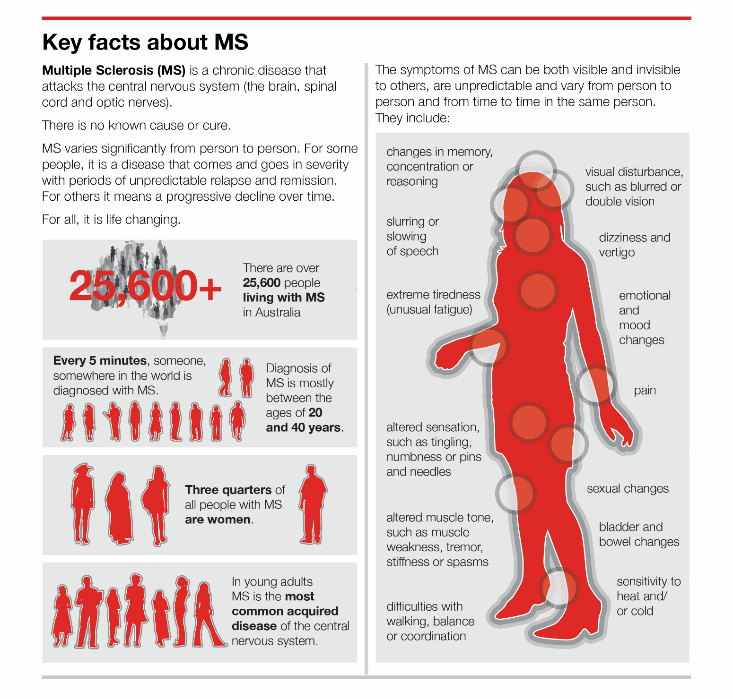

**About MS Australia**

MS Australia is the national peak body for people living with MS in Australia. Working on behalf of all state and territory-based member organisations to provide a voice for people living with MS across the country to support the development of:

• Research

• Advocacy and awareness

• Communication and information

• Services provided by our member organisations

• International collaboration.

MS Australia advocates across all stakeholders, governments and communities, on behalf of the members, to represent people who are diagnosed with the disease, their carers and the broader MS community.

MS Australia and MS Research Australia (the largest not-for-profit funder and coordinator of MS research in Australia) have recently amalgamated to form a newly focused MS Australia.

1. The Health Economic Impact of Multiple Sclerosis in Australia 2017 report, commissioned by MS Research Australia and prepared by the Menzies Institute for Medical Research, University of Tasmania, August 2018
2. https://www1.health.gov.au/internet/main/publishing.nsf/Content/health-care-homes
3. https://chf.org.au/media-releases/more-health-literacy-needed-stamp-out-fake-health-news
4. https://ama.com.au/sites/default/files/2021-01/Health%20Literacy%202021%20-%20AMA%20Position%20Statement.pdf
5. https://www.vu.edu.au/sites/default/files/mitchell-institute-self-care-for-health-a-national-policy-blueprint.pdf
6. https://www.clinicalguidelines.gov.au/
7. https://www.msbrainhealth.org/perch/resources/brain-health-time-matters-in-multiple-sclerosis-policy-report.pdf
8. https://www.msbrainhealth.org/perch/resources/brain-health-time-matters-in-multiple-sclerosis-policy-report.pdf
9. https://www.nice.org.uk/guidance/conditions-and-diseases/neurological-conditions/multiple-sclerosis
10. https://www.msbrainhealth.org/resources/article/ms-brain-health-consensus-standards
11. <https://www.aihw.gov.au/reports-data/australias-welfare/australias-welfare-snapshots>, p182
12. *Living with Multiple Sclerosis in 2019*, Key results from a quantitative research study commissioned by Multiple Sclerosis Australia, July 2019
13. https://www2.deloitte.com/au/en/pages/economics/articles/value-of-informal-care-2020.html